**Pages Needed**

* Landing / Login Page (Sam)
  + Purpose:
    - Entry Point – sign up or log in w/ @ucsc.edu email
  + Key Components:
    - UCSC logo + Potential SlugConnect logo
    - Email input
    - Sign up/login buttons
    - Authentication integration
* Onboarding Page
  + Purpose:
    - Collect students information after signing up
  + Key Components:
    - Form for name, major, college, year, interests (possibly multi-select tags)
    - Representing interests?
* Profile Page
  + Purpose:
    - View or edit your own profile
  + Key Components:
    - Avatar/Photo Upload, bio (?), editable form fields
* Browsing/Explore Page/Home Page
  + Purpose:
    - Browse and search student profiles
    - Browse interests/interests groups
    - Browse posts made by students (stretch goal?)
    - This would be the main page after creating a profile/signing up
  + Key Components
    - Search bar
    - Potential filters (major, year, college, interests)
    - Interests
* Connection Requests Page (stretch goal)
  + Purpose:
    - Manage connection invites
  + Key Components:
    - Tabs for “received” and “sent”
    - accept/reject buttons
* Nav Bar
  + Purpose:
    - Navigation between pages
  + Key Components:
    - Links between the home page, profile, explore/discover, …
* Chat (stretch goal)
  + Purpose:
    - Manage connection invites
  + Key Components:
    - Chat window w/ socket.io integration
* MVP
  + Browsing
    - search/filter by college, year, etc.
    - Filters for interests
    - Note: no college requirement for grad students
  + Preferred contact (discord, ig, etc.) – in regards to connection requests
  + Design pages needed for MVP
  + Interactions between pages

**Pages Cooked Up**

* Landing/Login Page
  + This is what the user will see when they first make a connection to our website
  + Design options can change (such as the color, font, etc.)

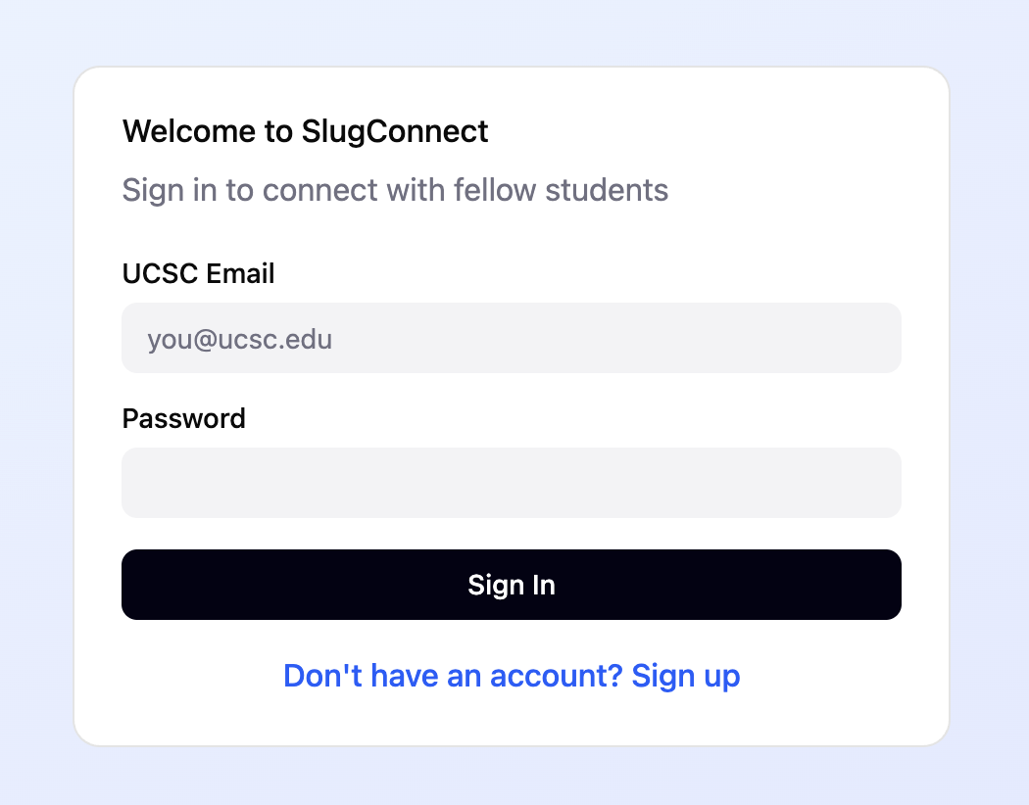

* + Links to the sign up page and the homepage (through sign in)

(This looks good to me, I will get to implementing it, I can also try to add the slugconnect logo even as a temporary logo - Sam)

* The Sign Up Page
  + This is where students will sign up with their email address and password if they don’t have an account yet

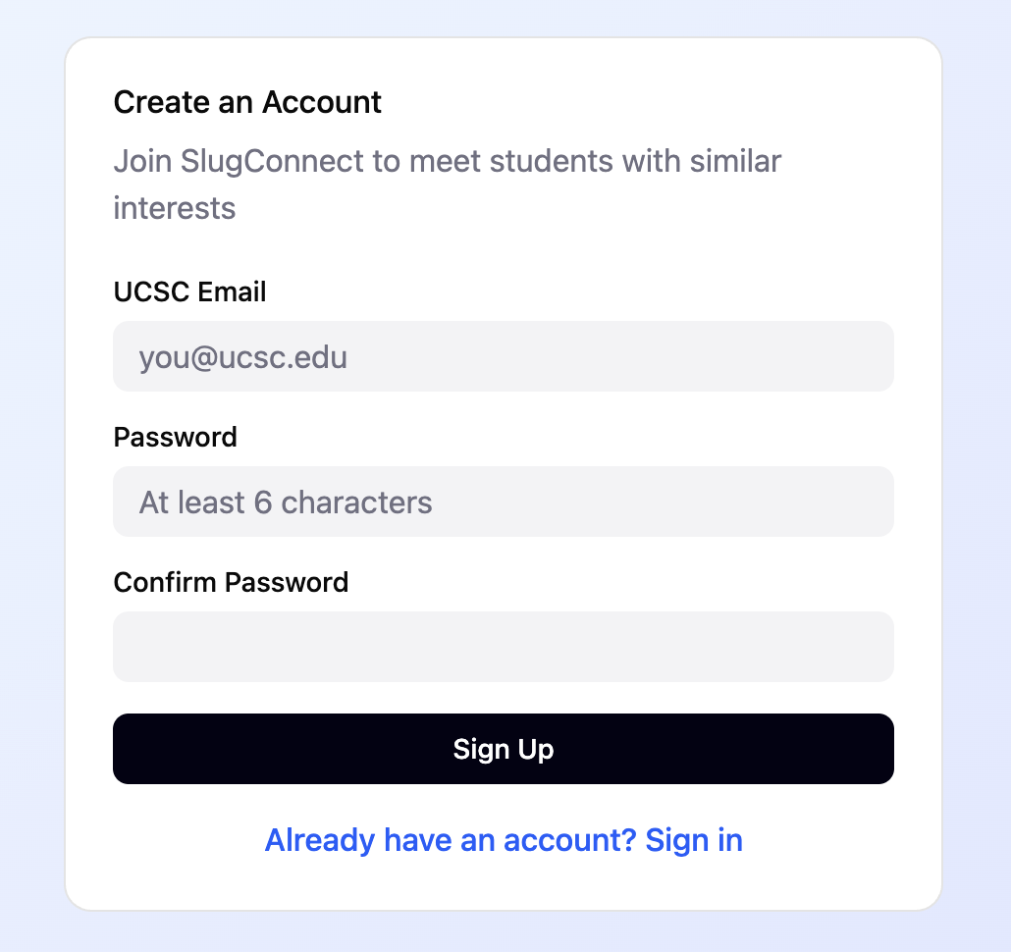

* + Links to the onboarding page (through sign up) and goes back to the sign in page
* Onboarding page

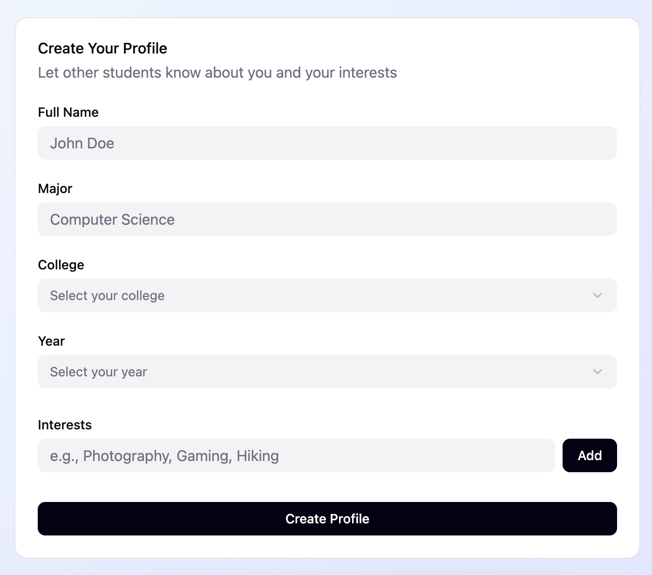

* + Where users will be able to create their profile and input things like their major, college (may be removed for grad students), year, and their interests
  + Links to the homepage (through the create profile button)
* Homepage/Browsing Page

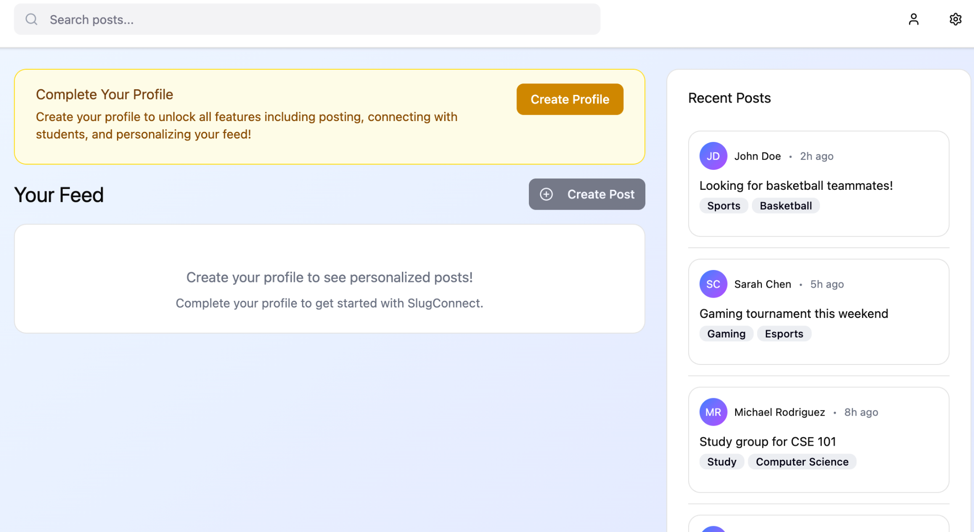

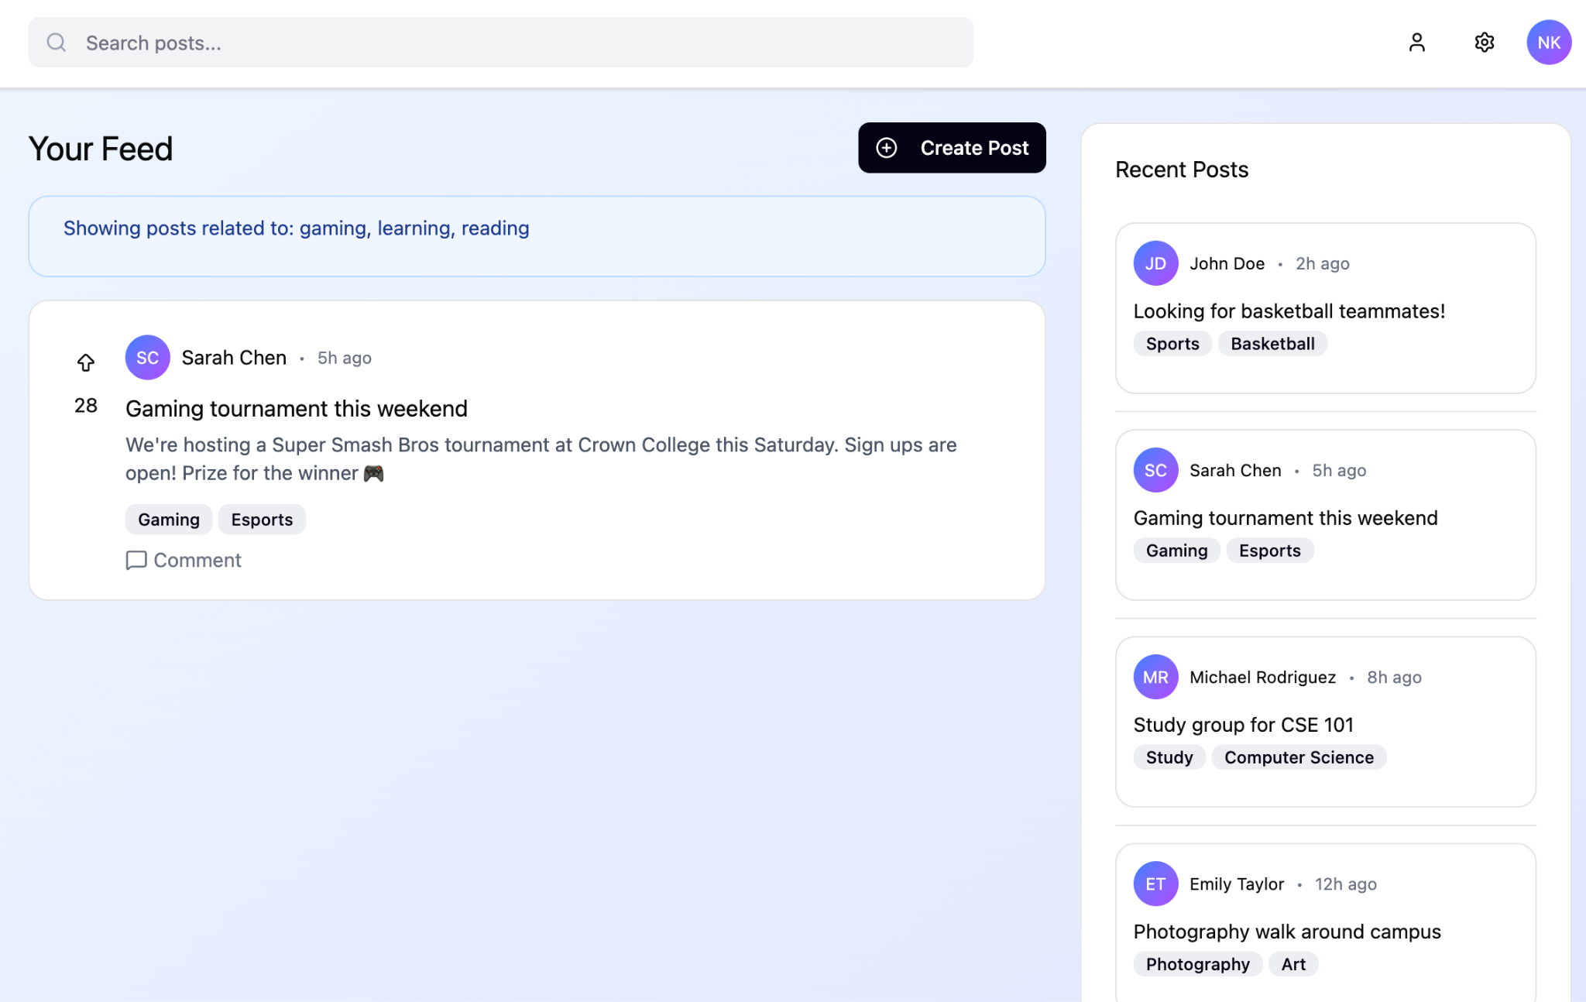

* + Can potentially click on posts made by other users which will then allow us to see that post
  + Homepage has the nav bar that allows users to navigate to their profile or to the settings page, and allows them to sign out
* Profile Page

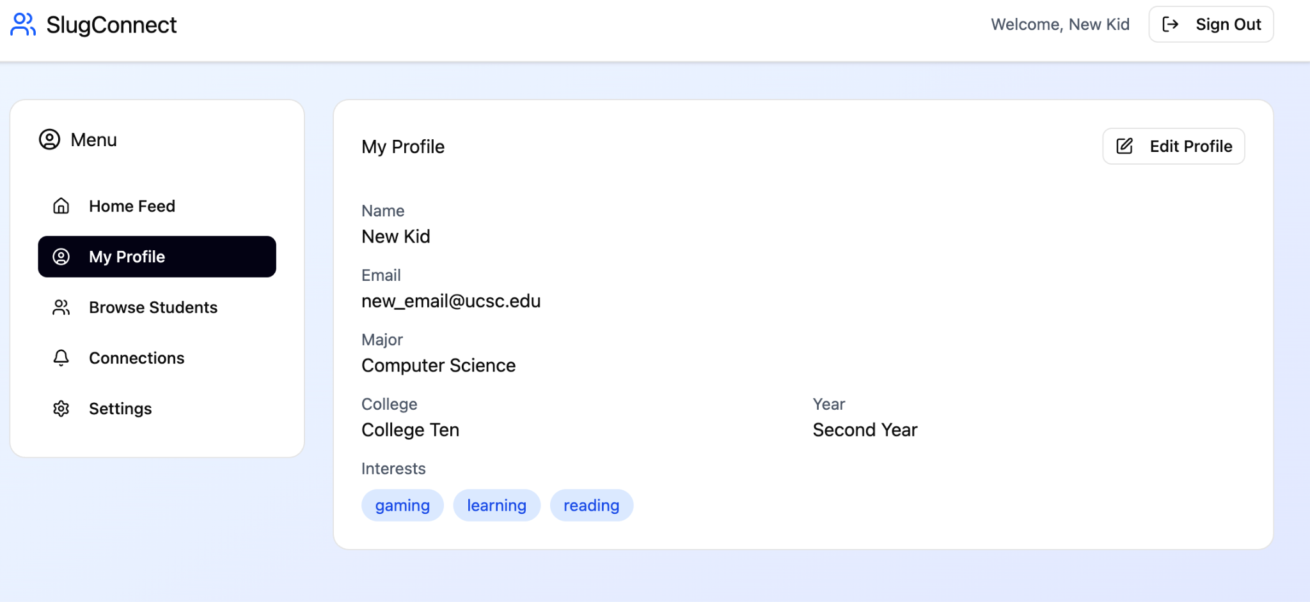

* + Allows users to edit profile
  + Links to other pages such as the homepage and settings

**Homepage Updated**

* Discover:

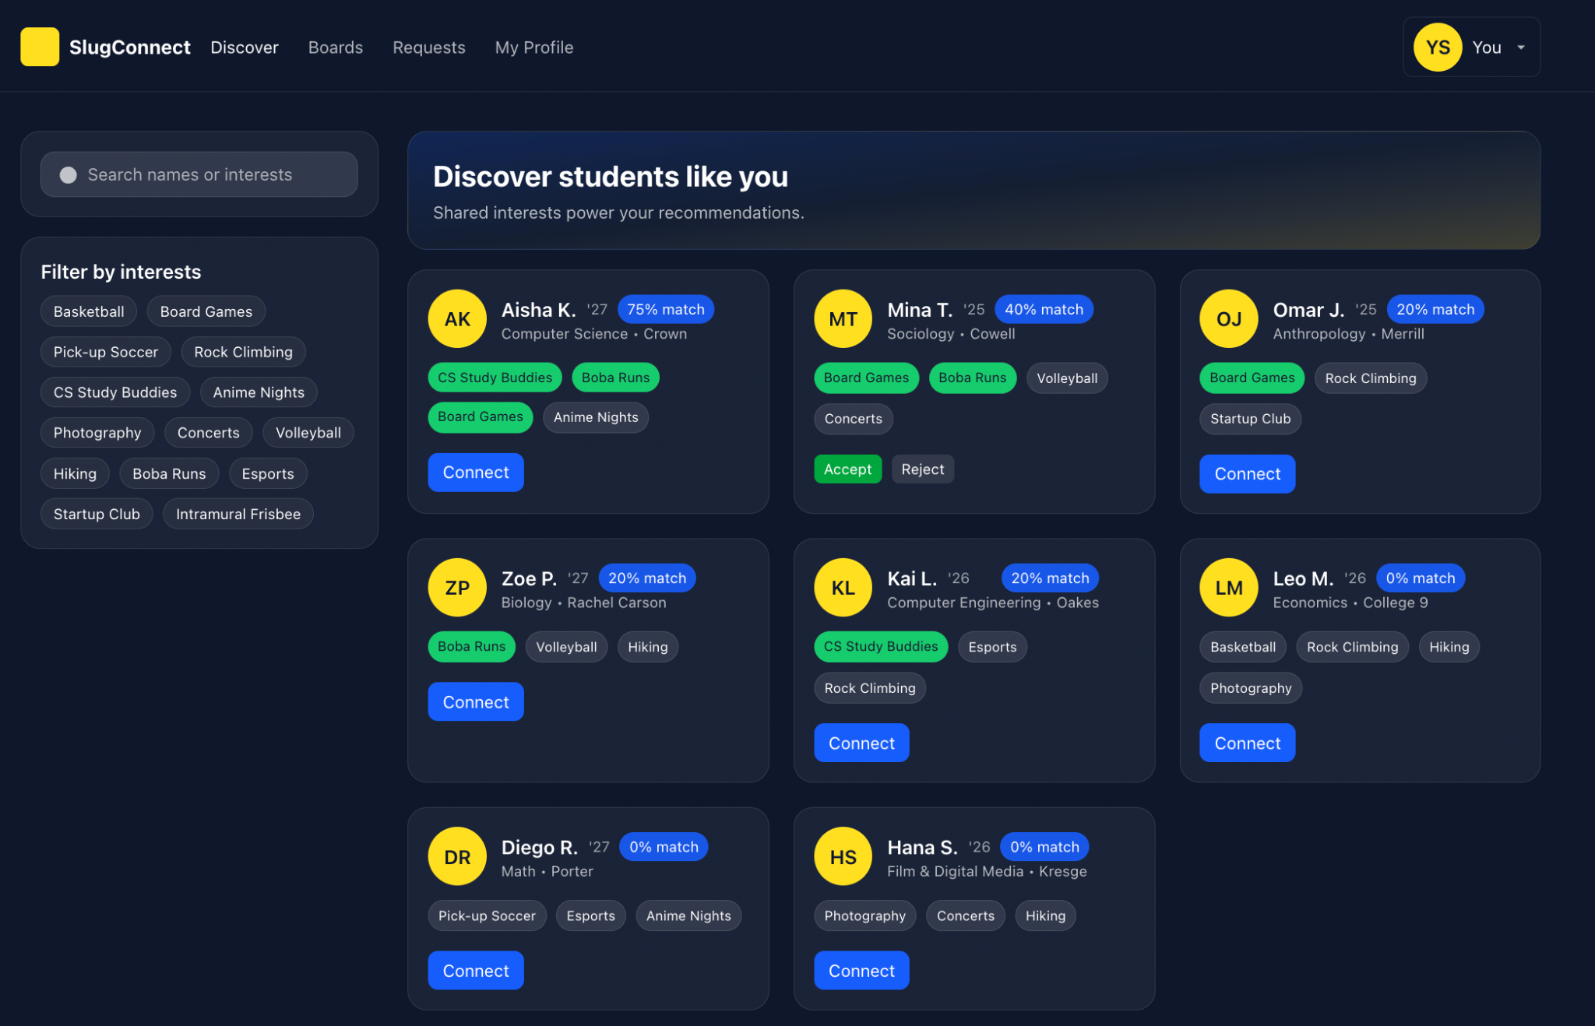

* Boards:

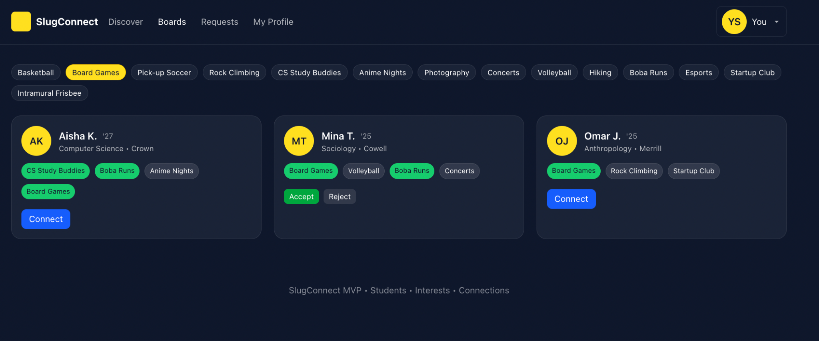

* Both meet the MVP and allow for filtering
* We can move stuff around if needed but I think we should keep the way the boards look (like displaying the name of the person, interest, and having the ability to connect with them through the button)
* We can get rid of things like “Discover students like you” in the Discover homepage idea
* Although im not sure what the implementation should be for accepting a connection (e.g. access to student profiles for accepted connections, potential messaging, etc.)